Tatu Bogdan – CTI EN 3.1

SCHMITT TRIGGER EDGE DETECTOR

Changed the Frequency → 200KHz (so some cases will have T1 < 2.2RC)

Changed the Input Voltage Amplitude & VDD → 1V (so Vx & Vout will drop to 0V, otherwise its about the same)

* 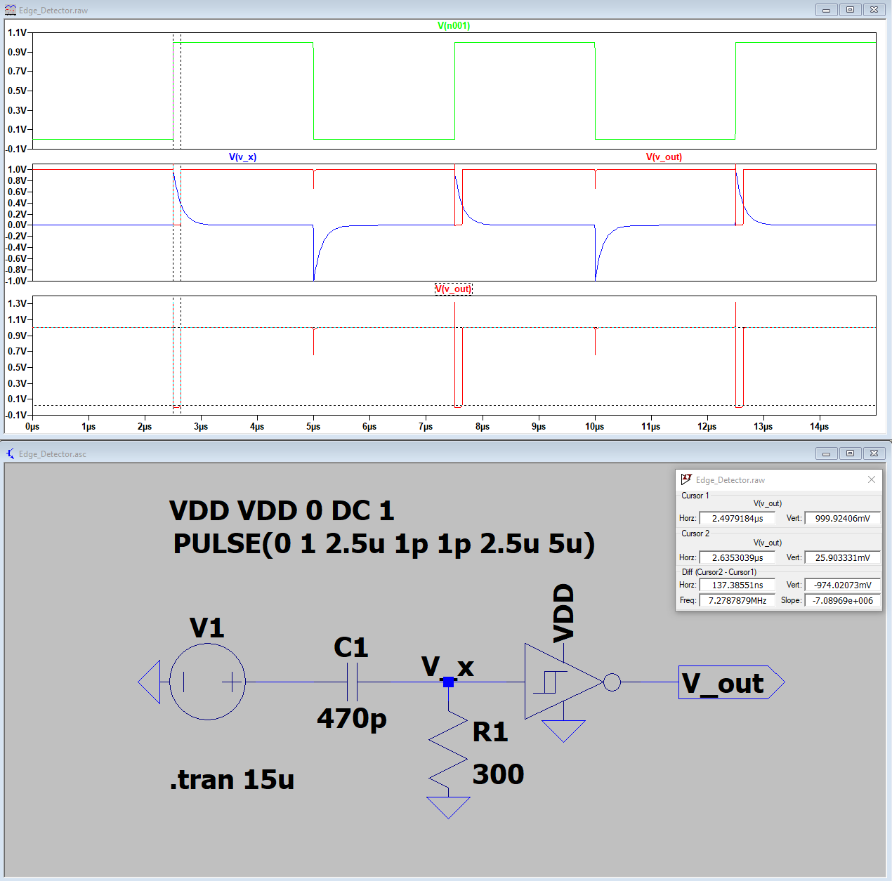C = 470pF R = 300Ω

Duration of Pulse: 137ns

* 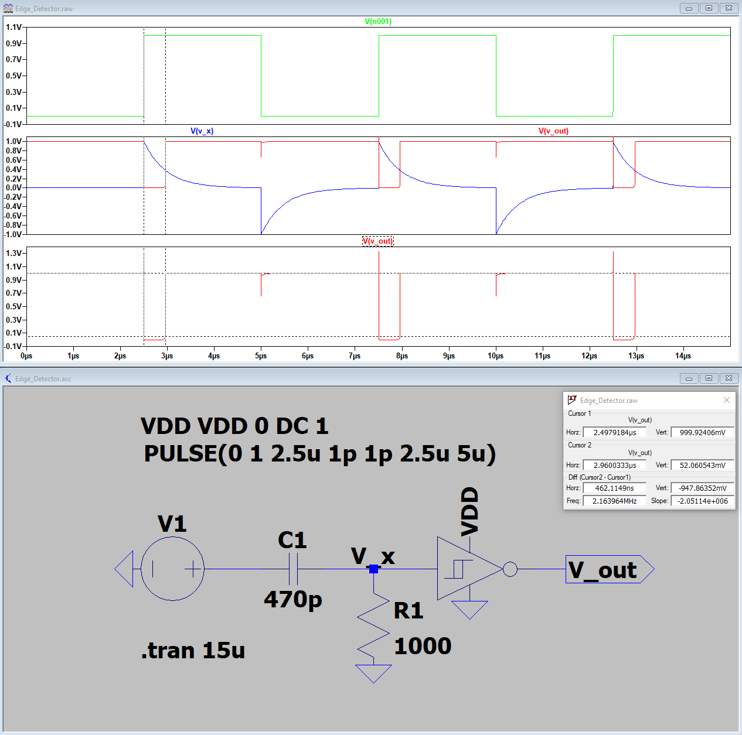C = 470pF R = 1000Ω

Duration of Pulse: 460ns

* 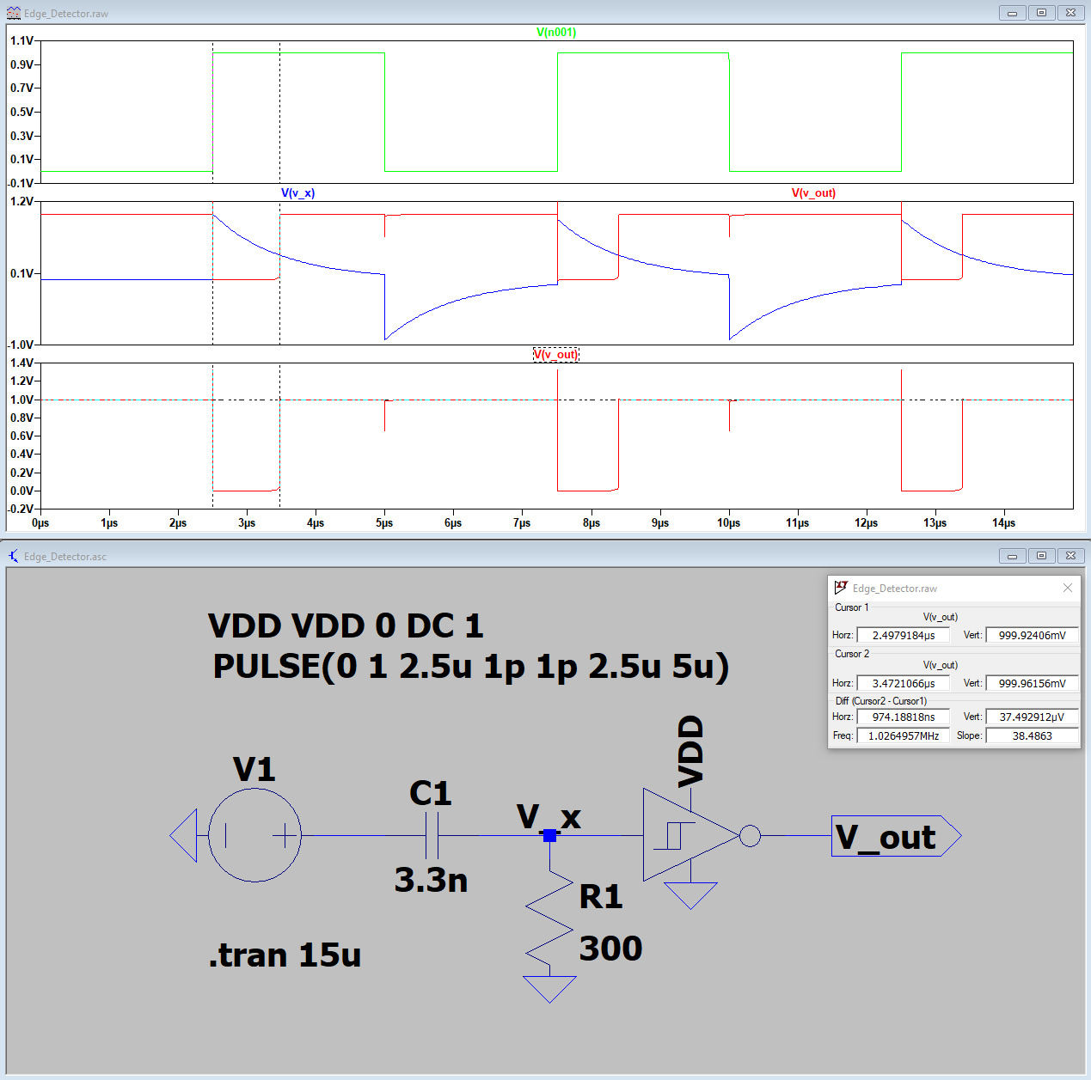C = 3.3nF R = 300Ω

Duration of Pulse: 974ns

* 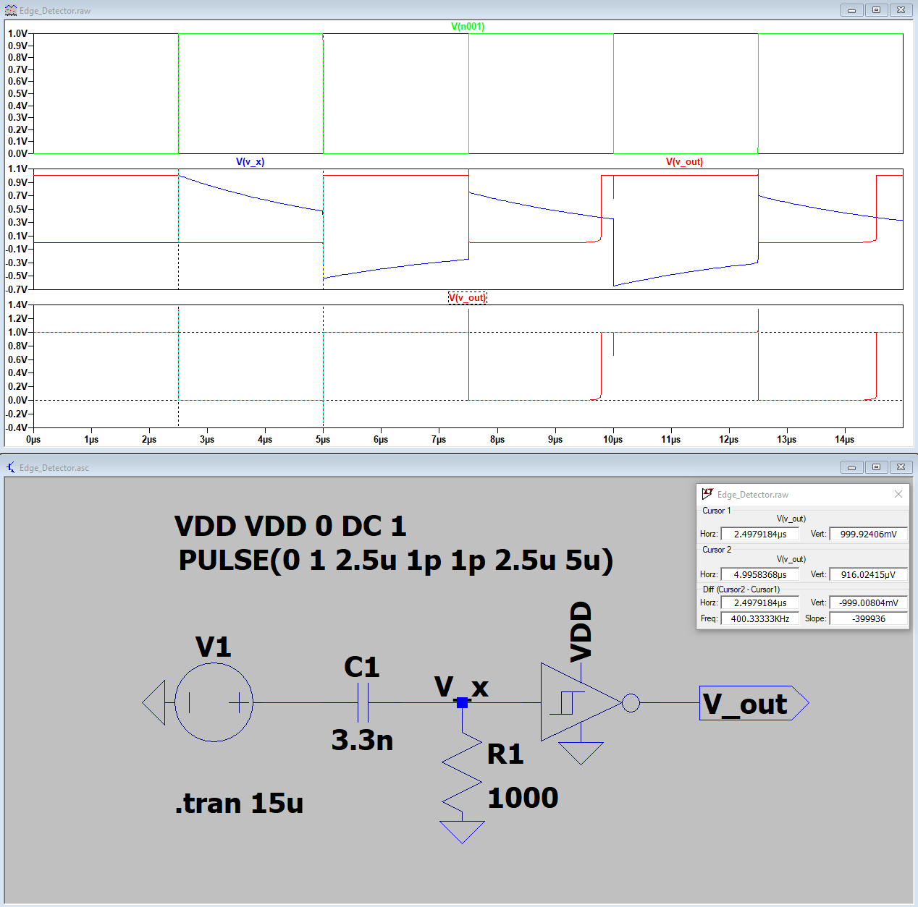C = 3.3nF R = 1000Ω

Duration of Pulse: ≈2.5μs = T1 of Input Voltage, since T1 > 2.2RC

* C = 470pF R = 300Ω
* 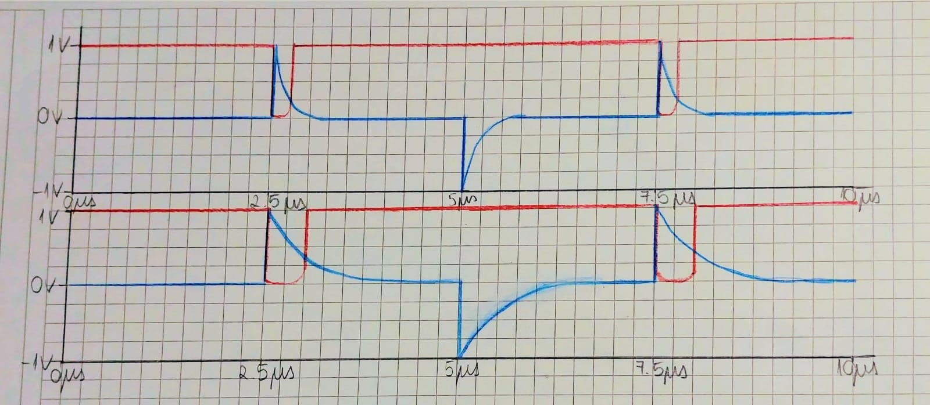C = 470pF R = 1000Ω
* C = 3.3nF R = 300Ω
* 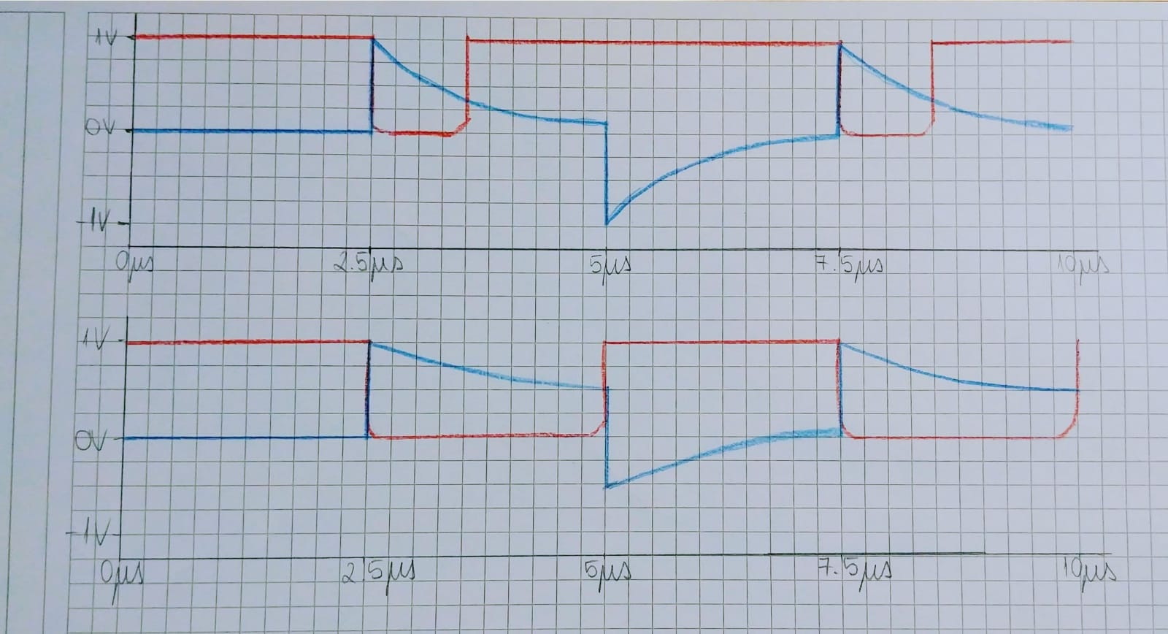C = 3.3nF R = 1000Ω

